The determination of significant factors that contribute to the chemical cell disruption of the microalgal species, *Nannochloropsis oculata*

**Abstract**

Biofuel commercialization is complicated because of the cell disruption step within its oil extraction process. The purpose of this study was to identify factors that affect chemical cell disruption of the microalgal species, *Nannochloropsis oculata*. JMP Software was used to develop a Resolution III screening design: a half fractional factorial design with four center points. The factors tested for significance were pretreatment method, buffer type, buffer volume, incubation time, and incubation temperature. Chlorophyll *a* is the only type of chlorophyll present in this species and has a narrow absorption band of 20nm. Therefore, a spectrophotometer used to measure the optical density of the lysate supernatant as the response variable. The experiment was statistically analyzed using JMP. Buffer type and volume were found to be the two most significant factors. Using 5 ml of ethanol to lyse 5 ml of algae sample volume proved most successful in lysing the cells.

**Background and Significance**

In 2018, transportation, including cars, trucks, and planes became the number one source of greenhouse gas emission in the United States, surpassing electricity (Milman 2018). A focus on discovering an environmentally friendly fuel has led scientists to work with algae to produce biofuel. The advantages of biofuel are extensive. Biofuel can decrease greenhouse gas emission and slow climate change. Furthermore, algae use sunlight as an energy source and consume CO2, which eliminates any competition for food sources.

As valuable as the benefits are of biofuel commercialization, the production process is complicated. Algae has a cell wall, generally multi-layer, that is thicker than that of bacterial cells. They are small in size, with a diameter of typical marine microalgae being approximately 2 to 3 micrometers (Kandilian et al. 2013). Mass production of biofuel will need an enormous volume of microalgae. The control of algae growth and the procedure for oil extraction becomes expensive. There have been many extraction methods, mechanical and non-mechanical, tested over the years. These include ultrasound-assisted extraction (UAE), hydrothermal liquefaction (HTL), and enzymatic disruption (Naghdi et al. 2016). Mechanical methods are often not economical because of high maintenance costs in addition to process cost. Enzymatic disruption is also high in cost because it is species dependent (Naghdi et al. 2016). In this study, a non-mechanical, chemical cell disruption method is designed. In order to determine the most effective way to lyse the cells, it is essential to understand the factors that are involved in the process and to establish the factors that affect the process the most.

The presence of chlorophyll *a* in the supernatant post cell lysis was measured. *N. oculata* has chlorophyll *a* as well as carotenoids in their cells, however, is absent of chlorophyll *b* and *c*. Chlorophyll *a* and carotenoids can both be detected by UV spectrophotometry (Fabrowska et al. 2018). The spectrophotometry was performed using a scan setting from 400nm to 700nm, at 10nm increments. Carotenoids have a broader absorption spectrum between 400-500nm (Fabrowska et al. 2018). Chlorophylls have a narrower absorption band of 20nm, therefore, the decision was made to use the absorption measurements that display maximum chlorophyll *a* content, approximately 662nm, as the response variable for this experiment (Dere et al. 1998).

This project tests five different factors of chemical cell disruption: pretreatment of cells, buffer type, buffer volume, incubation temperature, and incubation time. A blocking factor was added to account for the variation due to different operators. Four center points were included to account for any curvature in the model. The final design developed for this study was a Resolution III, half fractional factorial design, with four center points and a blocking factor with a total of 16 runs.

**Methods**

The 20% NaCl solution and lysis buffer were prepared and stored at 2°C. In preparation for the pretreated sample, a 50 ml conical tube of *N. oculata* culture was treated by resuspending the pellet with 50 ml of 20% NaCl solution after centrifugation at 3000 rpm for 10 min. Two 50 ml *N. oculata* culture had no pretreatment. All samples were stored at 2°C until cell lysis.

The algae sample volume was kept constant at 5 ml for cell lysis. 5 ml of the appropriate algae samples were aliquoted into sixteen 15 ml conical tubes. All 16 tubes were centrifuged at 3000 rpm for 10 min. 1 ml of each supernatant was kept to test for any premature cell breakage using spectrophotometry. The rest of the supernatant was discarded. The pellets were resuspended with the appropriate amount and type of lysing solution (ethanol or 1M NaCl, 70mM Tris, 30mM Na2EDTA buffer). The tubes were incubated in the specified environment. The 33°C incubation used a dry incubator, whilst for 66.5°C and 100°C incubation, a water bath was used. After the incubation period, the tubes were placed on ice immediately until all tubes had completed incubation. All tubes were centrifuged at 3000 rpm for 10 min. The supernatants were collected, and cell pellets discarded.

To analyze, 100 μl of the supernatants, previously saved, and the sixteen sample supernatants were aliquoted into the 96-well plate. A spectrophotometer was used to measure the absorbance from 400 nm to 700 nm, at 10 nm increments. The absorbance data and the graphs developed from the scan were used to determine the carotenoid and chlorophyll *a* presence in the supernatant by the position of the peaks. Chlorophyll *a* content between 660-670 nm specifically was used as the response variable.

**Results**

The results showed that buffer type and buffer volumes were the most significant factors contributing to the lysing of *N. oculata*. The averaged absorbance measurement was used as the response variable. The numbers were inserted and JMP generated an analysis.

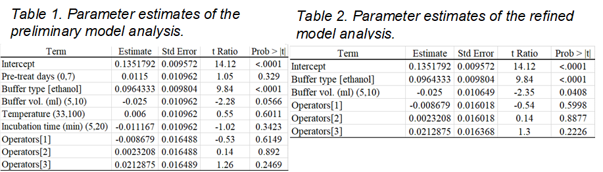In this experiment, a screening design was used to determine the individual significant factors that affect algae cell lysis. The ANOVA table for the preliminary model illustrated an F-ratio of 13.2027 and p-value of 0.0014; less than the specified alpha level of 0.05; indicating that the overall model is significant. This model described approximately 93.78% of the variation. In screening designs, the goal is to determine the factors that have significant effects on the response variable. The effects of the factors are described in the “Parameter Estimates” and “Effect Tests” tables (see Appendix Table 5). A p-value of less than 0.05 is used to determine the factor(s) which are significance in this model. Buffer type had the largest effect in the lysing of cells. The p-value for buffer type is ˂0.0001 and had the largest sum of squares, ~0.139. Although buffer volume had a p-value slightly larger than 0.05 at 0.0566, it had greater significance to the response of this experiment in comparison to the other factors in the study. Temperature was expected to be one of the significant factors when lysing microalgal cells. There are many methods including microwave-assisted extraction (MAE) and autoclaving that uses high temperature that are scientifically proven to lyse microalgal cells (Surendhiran et al. 2014). Unexpectedly, temperature had a p-value of 0.6011, suggesting that it had the least effect on the lysing of *N. oculata*.

A refined model was created keeping two significant factors; buffer type and buffer volume. The blocking factor was also kept in the refined model regardless of the higher p-value it generated in the preliminary model. (The high p-value, 0.5952, for operators show that having multiple operators did not cause an impact in the results.) ANOVA for the refined model resulted in an F-ratio of 21.87 and a p-value of ˂0.0001, an improvement from the preliminary model. This model accounts for approximately 91.62% of the variation. The lack of fit shows a small p-value, indicating that the model should be revised to include curvature. Within the refined model, all tested factors, buffer type and buffer volume, have small p-values. In the “Scaled Estimates” report, the estimated effects of the four operators can be seen. There is very little difference between the different operators. The “Prediction Profiler” suggests that to maximize response, absorbance from chlorophyll *a* content, the desirable condition for microalgae cell lysis is to use ethanol at a 1:1 ratio with the sample volume. With this setting, the maximum absorbance of approximately 0.257 with a 95% confidence interval between 0.217 and 0.296 is possible. The residuals produced from the model were studied. The distribution of the residuals was found to be normal. Constant variance and independence of residual points overtime was observed in the “Residual by Predicted Plot” and “Residual by Row Plot” generated; therefore, this model is acceptable.

**Discussion / Conclusions**

The statistical analysis using JMP determined the significant factors of this experiment; buffer type and buffer volume. Figure 1 graphically illustrates the comparison of two samples, the lowest and highest in chlorophyll *a* detection, for both factors. Ethanol clearly was the better lysing solution in comparison to the lysis buffer. This confirms our hypothesis that using acid is a better lysing chemical for microalgae, because it is closer in pH to the gastrointestinal environment of fish that are known to feed on the algae. Using 5 ml of ethanol resulted in higher absorbances in comparison to using 10 ml of ethanol. This can be explained by microalgae and lysing solution ratio. The results indicate that a 1:1 ratio of the microalgae and lysing solution is enough to break the cells open. Doubling the lysing solution does not improve the process; however, it diluted the concentration of the microalgae.

*factors, 1 blocking factor, and 4 center points.*

*Figure 1. Spectrophotometric scan from 400-700nm comparison of lowest and highest OD measurement for chlorophyll a presence. (a) Buffer types: low #2 with lysis buffer and high #9 with ethanol, (b) Buffer volume: low #3 with 10ml and high #9 with 5ml.*

The presence of the chlorophyll was also reviewed by visual inspection. *N. oculata* contains chlorophyll *a* which reflects green light. Thus, when the chlorophyll is contained within the cell membrane, the cell will look green. The cell wall composition of microalgae is approximately 80% cellulose and polysaccharide known as sulfated fucans, which is yellowish white in color (Corteggiani et al. 2013). After centrifugation of successfully lysed microalgae samples, white cell debris is observed at the bottom of the tubes and the supernatant is green indicating chlorophyll presence. These visual inspections matched the statistical results. Dark green supernatants yielded higher absorbance measurement.

Overall, ethanol proved to be a good lysing solution because of its low pH and polarity. Lipids that are used for biodiesel are non-polar; however, lipids of the cellular membrane are polar (Naghdi et al. 2016). Therefore, a polar solvent such as ethanol will help dissolve the lipids and disrupt the morphological structure of the microalgae. A 1:1 ratio of microalgae and ethanol is adequate for successful cell disruption. To optimize this cell disruption method, different concentrations of ethanol should be tested. Also, other acids should be tested to determine the most cost effective and less harmful to the environment solvent.

References

Corteggiani Carpinelli, E., et. al. (2013). Chromosome scale genome assembly and transcriptome profiling of Nannochloropsis gaditana in nitrogen depletion. Molecular Plant. 7 (2): 323-335. doi:10.1093/mp/sst120.

Dere, S., Gunes, T., et. al. (1998). Spectrophotometric Determination of Chlorophyll – A, B, and Total Carotenoid Contents of Some Algae Species Using Different Solvents. Tr. J. of Botany, 22, 13-17.

Fabrowska, J., Messyasz, B., et. al. (2018). Isolation of chlorophylls and carotenoids from freshwater algae using different extraction methods. *Phycological Research*, 66, 52-57, doi: 10.1111/pre.12191 Retrieved from https://onlinelibrary.wiley.com/doi/abs/10.1111/pre.12191

Kandilian, R., et. al. (2013). Radiation and optical properties of Nannochloropsis oculata grown under different irradiances and spectra. Bioresource Technology. 137: 63-73. doi:10. 1016/j.biortech.2013.03.058.

Milman, O. (2018). Vehicles are noe America’s biggest CO2 source but EPA is tearing up regulations. The Guardian. Retrieved from https://www.theguardian.com/environment/2018/jan/01/vehicles-climate-change-emissions-trump-administration

Naghdi, F.G., Gonzalez, L.M., et. al. (2016). Progress on lipid extraction from wet algal biomass for biodiesel production. Microbial Biotechnology, (2016)9(6), 718-726, doi: 10.1111/1751-7915.12360. Retrieved from https://www.ncbi.nlm.nih.gov/pmc/articles/PMC5072188/

Surendhiran, D., & Vijay, M. (2014). Effect of Various Pretreatment for Extracting Intracellular Lipid from *Nannochloropsis oculata* under Nitrogen Replete and Depleted Conditions. Hindawi Publishing Corporation ISRN Chemical Engineering, volume 2014, 536310. http://dx.doi.org/10.1155/2014/5356310 Retrieved from https://www.hindawi.com/journals/isrn/2014/536310/

Appendix

*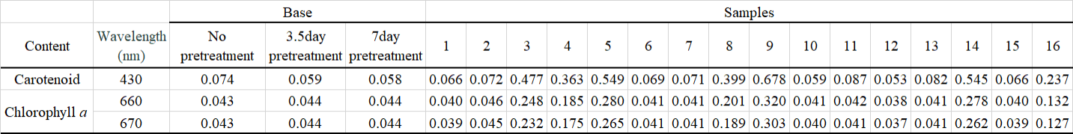Table 3. Chlorophyll and carotenoid content detection from retrieved supernatant post cell lysis using spectrophotometry.*

*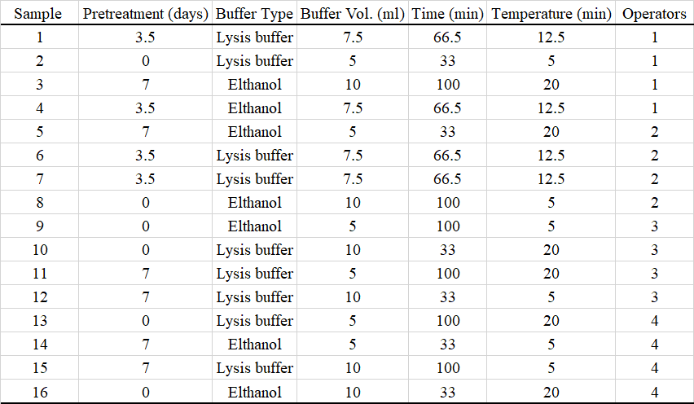Table 4. Design table generated by JMP; one half fractional factorial design with 5 experimental factors, 1 blocking factor, and 4 center points.*

*Table 5. Effect tests of the preliminary model analysis.*

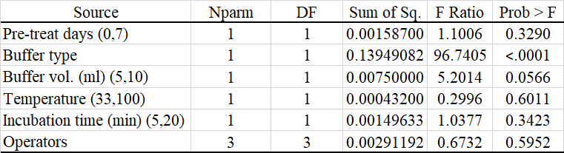

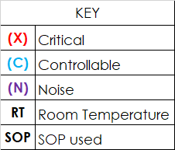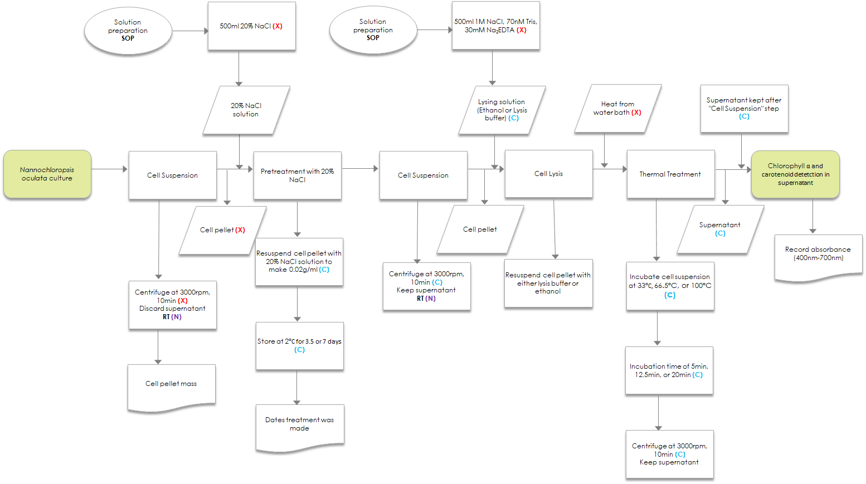

*Figure 2. Process map of N. oculata lysis using IC-Six Sigma-Process-Map template.*