Sharper Whites and Brighter Brights: Cost Effective Stain Removal for College Students

Abstract
Students often find it hard to balance budgets and effective removal of clothing stains encountered in daily college activities. Thus, we designed an experiment to determine the most cost-effective and efficient way of removing commonly encountered stains. In this experiment, we used a three-way ANOVA to test the effects of different factor combinations of time, stains, and detergents on stain removal. Our results indicate that all factors have statistically significant impacts on our response variable, percentage change in the color of the stain. Additionally, we find an interaction between time and stains, suggesting the removal of certain stains should be prioritized over others. We also find an interaction between detergent and stain type implying that specific detergents might be better at removing certain stains over others.

Introduction
While detergents are a commonly used household good throughout the US, up to 29.3% of American consumers are unhappy with the lack of stain removal capability in common detergents (Ferri et al. 2016). This issue is certainly applicable to college students as well. However, the constraints of a student’s budget may leave them ill-equipped to deal with clothing stains in a college setting.
To find the most cost effective yet time efficient way of dealing with dirty stains, we conducted a three-way ANOVA test using different factor-level combinations of time, stain type, and detergent. The various stains we chose are commonly encountered on a college campus. In order to examine both conventional cleaning agents and other low-cost alternatives, we used both store-bought detergents and home-made remedies. Lastly, the time levels simulated the proactiveness of different college students. To gauge their effectiveness in removing stains, we used percent change in the color of the stain as the response variable.

Methods
We stained 64 six-inch squares of 100% white cotton cloth with one of the four common stains (red wine, coffee, ketchup, Expo marker). A constant amount of a stain was applied to each piece of cloth using the following measurements: 1 tbsp red wine, 1 tbsp coffee, 1 square inch green expo-marker stain, and a 9 gram packet of ketchup. Half of the clothes were washed an hour after the staining process while the other half were washed 24-hours later. Before completing any washes, we measured the RGB values of both the stained portion of the cloth (unwashed) and the unstained portion of the cloth (standard) using the ColorName application from the Apple Store (highest rated color measurement app, developer - Vlad Polyanskiy) on a standard iPhone 7. We then included a cloth with each type of stain in each load of laundry, for a total of four cloths per load, along with one of the four chosen detergents (Tide pods, generic pods, generic pods + ¼ cup baking soda, ⅓ cup vinegar). These washes were run in duplicates. In order to control for confounding factors, we used the same type of washing machine (Speed Queen - Front Load Washer), wash settings (delicate warm wash) and ran each cycle for 25 minutes. After each wash, the four cloth pieces were dried in the same dryer at high heat for 30 minutes.
After completing the washes, we measured the RGB values of the remaining stain on each washed cloth to gauge the percent change in the color of the stain. To simplify our subsequent calculations, we converted the RGB values to grayscale using the following equation (Iwaki, Y. 2014):
grayscale = (0.3)*R + (0.59)*G + (0.11)*B
Using grayscale values, we calculated the stain before being washed as [standard – unwashed]. Similarly, the stain after being washed was measured as [standard – washed]. We then calculated percent change in the color of the stain as:
% change = 100*((standard - unwashed) - (standard - washed))/(standard - unwashed)
With the data having been collected, we used R software to analyze the following model:
Y_{ijk} = α_{i} + β_{j} + η_{k} + αβ_{ij} + αη_{ik} + βη_{jk} + ε_{ijk}
In this model, Y_{ijk} is the percent change in stain, α_{i} is the fixed effect of stain i, β_{j} is the fixed effect of detergent j, η_{k} is the fixed effect of time, αβ_{ij} is the interaction of stain i with detergent j, αη_{ik} is the interaction of stain i and time k, βη_{jk} is the interaction of detergent j with time k, and ε_{ijk} is the error term. With this model, we assume that the error term is independent and normally distributed with mean zero and constant variance.

Results
We ran a three-way ANOVA testing both the main effects and interactions to determine the significance of this model. The residual vs. fitted value plot and Normal Q-Q plot, despite a few outliers on either end of the plot, show that we sufficiently met the assumptions of equal variability within groups and normality, respectively (Appendix Fig. 1). We found that all three factors had a significant effect on percent stain removal (stain: F=151, p<.001; time: F=135, p<.001; detergent: F=16.9, p<.001, Table 1). The main effects plot of stain on percent change in stain (Fig. 1.b) shows that ketchup was the easiest stain to remove, coffee and wine provided equally challenging stains to remove, and expo marker was the most difficult stain to remove. The main effects plot of time on percent change in stain (Fig. 1.a) suggests that proactive washing of stained items led to the most effective stain removal (1 hour: 67.1%, 24 hours: 41.0%). As expected, the main effects plot of detergent (Fig. 1.c) depicts that generic pods (60.1%) and Tide pods (63.6%) provided a more effective method to remove stains than the use of baking soda (45.4%) or vinegar (46.9%).
The significant interactions provide perhaps more interesting results. The interaction of stain and time was significant (F=7.66, p<.001, Table 1), which suggests that the effect of stain on percent change in stain depended on the amount of time between staining the cloth and washing the cloth. Although this interaction may not be evident in the interaction plot of stain and time (Fig. 2.a), we do see slight variation between the lines representing one hour and 24 hours (Figure 1). Similarly, the interaction between stain and detergent was significant (F=4.18, p<.001, Table 1) suggesting that the effect of stain on percent change in stain depended upon the detergent being used. The interaction plot of stain and detergent on percent change in stain provides a useful visualization of this interaction (Fig. 2.b); for each staining agent other than wine, Tide pods provided the most effective way to remove the stain. However, the generic pods were most effective in removing a wine stain. Additionally, baking soda acted as a better stain removal agent than vinegar for ketchup (baking soda: 86.5%, vinegar: 82.0%) and Expo marker (baking soda: 18.1%, vinegar: 11.9%) while vinegar acted as a better stain removal agent for wine (baking soda: 44.8%, vinegar: 47.5%) and coffee (baking soda: 32.2%, vinegar: 46.3%).

Figure 1. Main Effect Plots. From left to right: time (a), stain (b), detergent (c).
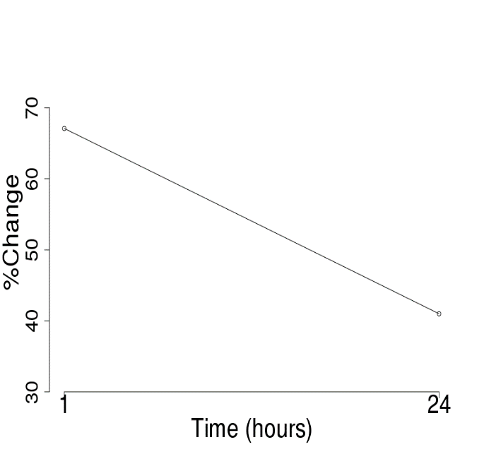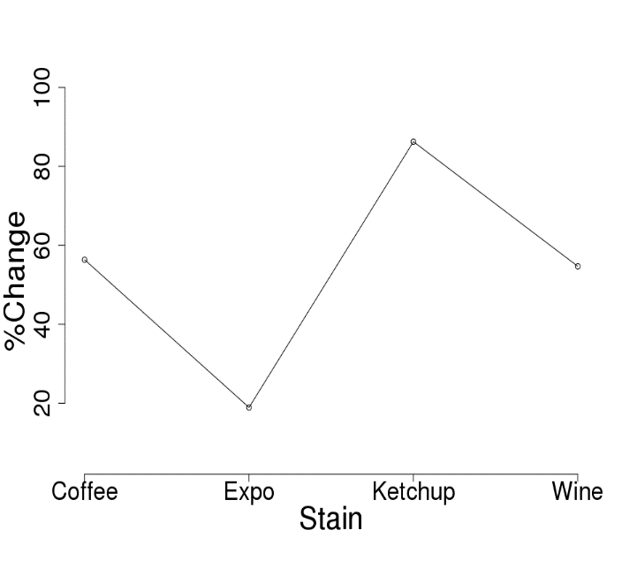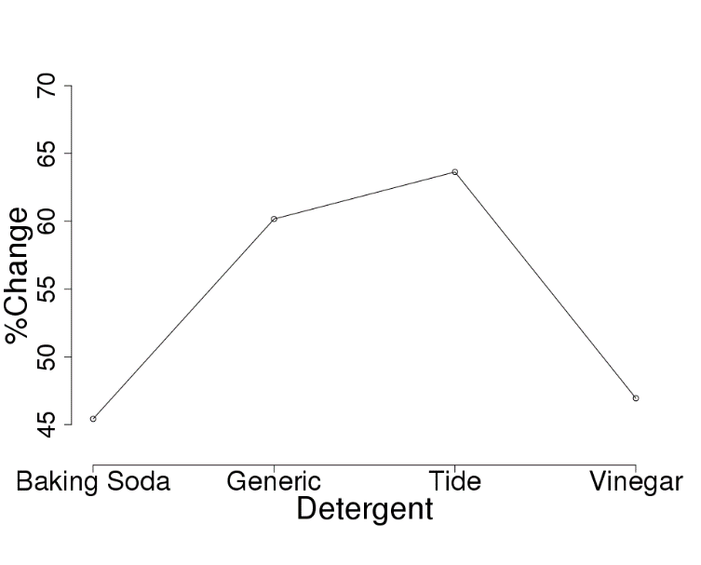
Figure 2. Interaction Plots. The left plot (a) shows the interaction of stain and time while the right plot (b) shows the interaction of detergent and stain.
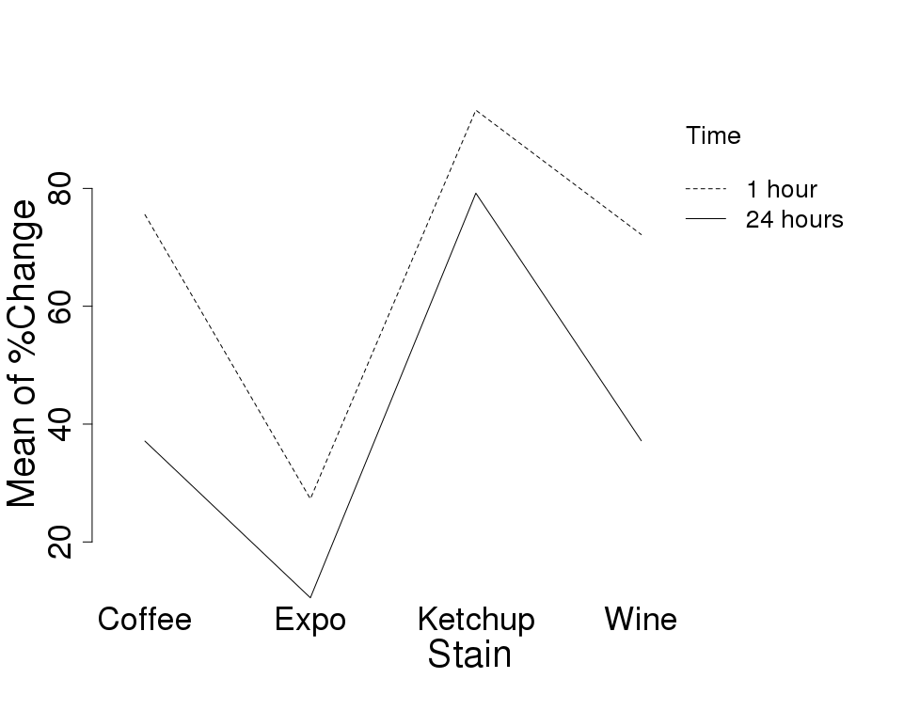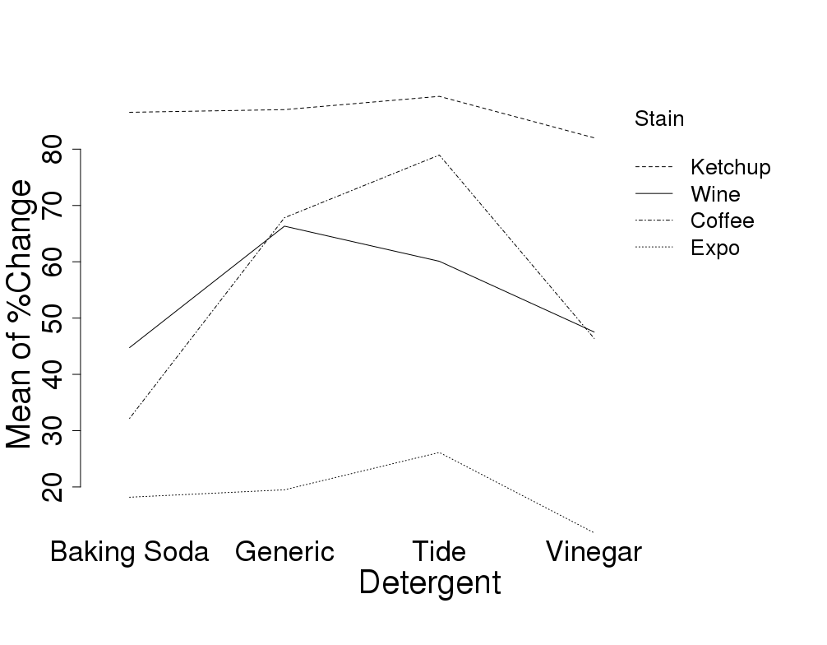

Table 1. ANOVA Results. Results of the model explained in the methods section. * represents a significant factor or interaction.
Factor | Df | Sum of Squares | Mean Squares | F-value | P-value
Stain | 3 | 36418 | 12139 | 151.465* | <2e⁻¹⁶*
Time | 1 | 10876 | 10876 | 135.708* | 1.38e⁻¹⁴*
Detergent | 3 | 4070 | 1357 | 16.928* | 2.64e⁻⁰⁷*
Stain•Time | 3 | 1848 | 616 | 7.688* | 0.000345*
Time•Detergent | 3 | 335 | 112 | 1.392 | 0.258761
Stain•Detergent | 9 | 3017 | 335 | 4.183* | 0.000696*
Residuals | 41 | 3286 | 80 | - | -

Discussion
The results of our analysis are mostly consistent with our predictions. As expected, some stains were stronger than the others (Expo being the strongest; ketchup being the weakest). In a similar vein, the interaction term suggested that the stains, especially that of coffee and wine, become harder to remove as time goes by. Thus, we recommend that stains should be washed as soon as possible in order to increase chances of stain removal. Additionally, given that our results indicate that Tide pods are only slightly better at removing stains compared to generic pods and that Tide pods are much more expensive than the generic ones, generic pods are preferable to Tide pods.
In terms of home remedies, we suggest vinegar over baking soda as it is not only cheaper (baking soda must be used with pods), but performed better overall in stain removal. Baking soda, in contrast to the Arm & Hammer claims of enhancing stain removal, actually performed worse than using the generic pod alone, which led us to conclude that baking soda reduced the efficacy of the detergent and should not be used as an additive to laundry detergent for the removal of coffee, expo, wine, and ketchup stains.
The main limitation of our model stems from the high degrees of freedom. Although our results suggest that the stain and time interaction is significant, Figure 2 indicates that there is minimal interaction between the two factors. This is likely caused by the deflation of the p-value due to the high degrees of freedom, which makes the interaction term appear significant when in reality it might not be. Thus, we cannot entirely rely on p-values in this model.
Although our use of white cotton cloth for our tests limits the generalizability of our results to other fabrics, we can likely generalize these results to white and possibly other light colored cotton cloths. Moreover, since the detergents we used are readily available detergents in most parts of the US, we can conclude that these results can be applicable to college students dealing with stains on light cotton items across the country.
Overall, we recommend that college students should avoid using baking soda, should not allow stains to sit for large amounts of time, and should use generic detergents to get the most value for their money, although the interaction between stains and time should be investigated more thoroughly in future work.

References

Ferri, Ada & Osset, Miquel & Abeliotis, Konstadinos & Amberg, Caroline & Candan, Cevza &
Owens, Jeremy & Stamminger, Rainer. (2016). Laundry Performance: Effect of Detergent and Additives on Consumer Satisfaction. Tenside Surfactants Detergents. 53. 375-386. 10.3139/113.110451.

Iwaki, Y. (2014). U.S. Patent No. 8,861,878. Washington, DC: U.S. Patent and Trademark
Office.

(n.d.). How to Get Laundry Extra Clean and Fresh with Baking Soda. Retrieved from
https://www.armandhammer.com/articles/how-get-laundry-extra-clean

Polyanskiy, Vlad. (2014). Color Name AR (2.0) [Mobile Application Software].

Appendix:

Figure 1. Model Diagnostic Plots. On the left is the Residuals vs. Fitted Values Plot of the model stated in the methods section. The residuals appear to have a mean of zero, constant variance across the fitted values, and there does not appear to be autocorrelation. On the right is the Normal Q-Q plot of the model stated in the methods section. Other than a few outliers at the extreme values, the residuals appear to be fairly normally distributed.
