The Effect of Music on the Ability to Focus

Abstract

It is common for people to listen to music as a part of their daily routines. This typically occurs in the context of performing other tasks at the same time. This study was designed to evaluate the effect of music on the brain and our ability to accomplish everyday tasks efficiently. This study examines both the effects of type and tempo of the music a person listens to while completing a task on the time needed to complete that task. Participants were asked to complete a simple jigsaw puzzle while listening to songs of various type and tempo combinations. Results from a repeated-measures ANOVA model indicate an important two-way interaction between tempo and type of music. They suggest that fast-paced instrumental music may be useful for focus.

Background

Today’s world moves so quickly, that it can be very easy to get distracted while trying to get work done. This can result in a task that should take thirty minutes actually taking hours to complete. Many people listen to music while performing everyday tasks, like exercising, working on homework, or doing chores. There are mixed opinions on whether or not music can be beneficial in helping one focus on the task at hand. The goal of this study is to determine if the type (vocal/instrumental) and tempo (fast/slow) of music affects a person’s ability to focus on a task and complete it efficiently. Determining if characteristics of music affect the ability to focus could allow a person to select music that will benefit them by helping them to complete tasks quickly.

Methods

Study participants consisted of a mix of university students and faculty. Two levels of each factor were considered: slow vs. fast tempo and vocal vs. instrumental music. This resulted in four total treatment combinations, each represented by a different pre-selected song. Participants were asked to complete a basic jigsaw puzzle (24 pieces) online while listening to one of the four songs that matched one of the treatment combinations. Once the puzzle was completed, it was reset, and the participant was asked to complete it again with a different type/tempo combination. Each participant completed the puzzle a total of four times, once for each factor level combination. Two measures were taken to account for the likelihood that participants improve from one trial to the next. First, the attempt number was included in the analysis. Further, the 24 study participants each completed the study using a unique order of the songs (all possible orderings were represented). For each trial, the time taken to complete the puzzle was recorded as the response variable.

A repeated measures ANOVA procedure was used to test for a difference in mean completion time between the two levels of each factor. Subject and phase (attempt number) were both analyzed as blocking factors, with subject treated as random and phase treated as fixed. Type and tempo of the music were considered the main factors of interest. Two way interactions were incorporated into the model.

Analysis

Based on graphical methods, there is no concern over a violation of the ANOVA assumptions of normality and constant variance of the errors. There is evidence of a type/tempo interaction (F = 12.95, p-value = 0.003), a phase/tempo interaction (F = 3.97, p-value = 0.031), and a phase/type interaction (F = 5.25, p-value = 0.012). There is also significant evidence of subject/type and subject/tempo interactions (see ANOVA table below). Based on the interaction plot for the primary factors of interest, it would appear that for fast music, instrumental is better, but for slow music, vocal may be slightly better.
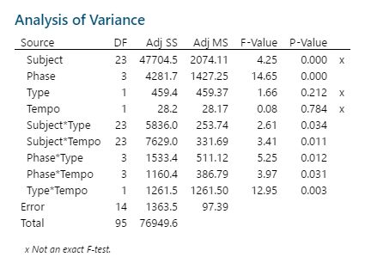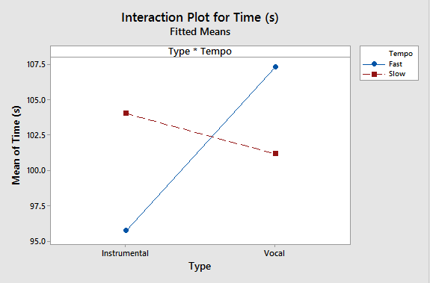
As expected, there was significant evidence of differences in the mean completion time due to the phase, implying that people did get quicker as they completed successive attempts of the puzzle. Interactions with phase were found to be significant, but interaction plots suggest that this interaction is minor and probably not relevant to the research question. Interactions containing subject were also significant, suggesting there may be differences in what types of music are best for each individual. So while this study makes some generalizations to a larger population, it is likely most effective to manage effects of type and tempo on an individual basis.

Tukey groupings of the type/tempo interaction indicate that fast-paced instrumental music results in a quicker mean completion time as compared to both fast vocal music and slow instrumental music. There was no evidence of a difference between slow vocal music and fast instrumental music. The groupings reflect what is seen in the interaction plot. For fast tempo music, choosing instrumental music will be significantly beneficial. It is estimated that listening to fast instrumental music rather than fast vocal music will decrease mean completion time by between about 3.4 and 19.9 seconds. For slow tempo music, there may not be an important difference between vocal and instrumental music (based on the interval estimates above, there may be an average difference as high as 11 seconds). Further study with a larger sample size would be needed to further clarify whether an important difference exists here.

Discussion/Conclusions

Based on the results, there is evidence that the type of music a person listens to affects his or her ability to focus on a task, in this case, completing a jigsaw puzzle. The interaction of tempo and type of music indicates that different tempos may be beneficial for different types of music. Results suggest that if a person chooses to listen to fast-paced music, it would be more beneficial to concentration if it is instrumental. While fast tempo music may stimulate the brain enough to help someone focus, the added component of lyrics could interfere with concentration and make it difficult to complete a task efficiently. There was no evidence of a difference in completion time between instrumental and vocal music that is slow-paced. No evidence was found of a difference in fast and slow vocal music, but evidence suggests that if a person chooses to listen to instrumental music, a fast tempo is more beneficial. This study was unable to distinguish between tempos for vocal music as well as between types for slow music, an indication that the study did not have the statistical power desired. Wide Tukey intervals imply that practically important differences may exist, and a new study with more replications would be required to test for these differences.

The results indicated that there could be up to a twenty second difference in mean completion time between different types of music. The 24-piece puzzle took an average of 102 seconds among study participants. During the course of a day, tasks may add up to hours of work. Therefore, if the results of this are generalized to a setting in which a particular task may take hours, the difference in completion time would be more substantial. For those of us that can’t do work without listening to music, the characteristics of the music we choose may be significantly beneficial in helping save time on the necessary tasks of life, leaving more time for more enjoyable activities. Furthermore, as indicated by the numerous additional interactions significant in the model, the type of music that works best almost surely depends to some extent on the individual. Therefore the recommendation that seems to work best for most should not be assumed to work best for all. Applications to a group scenario (e.g. a workplace) may choose to use fast-paced instrumental music for best results, but those working individually are likely better off with a more individualized plan.

Future Work

Further studies with larger sample sizes would be needed to examine differences deemed insignificant by the results of this study. A future study would include a control level (no music at all) to test for an overall benefit of music to concentration. An interesting variation of this study would be to perform it in a workplace situation where it is important to not only complete tasks efficiently, but proficiently as well. Another possible factor that may be of interest is whether or not a person is familiar with the music used in the study, as this may affect how much they pay attention to the song playing and subsequently how much they can focus on the task at hand.

Appendix

Link to puzzle used:

https://www.jigsawplanet.com/?rc=play&pid=10d3de9677dc

Songs used:

Vocal/Slow: Youth by Daughter
Vocal/Fast: Called Out in the Dark by Snow Patrol
Instrumental/Slow: Smokey Mountain Lullaby by Tommy Emmanuel
Instrumental/Fast: Glimmering Lights by The Album Leaf

Variance results of the ANOVA indicate that there is substantial subject-to-subject variability.

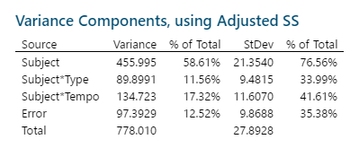

Interaction plots for phase/type and phase/tempo interactions.

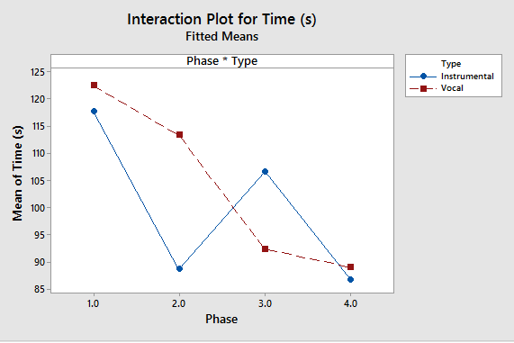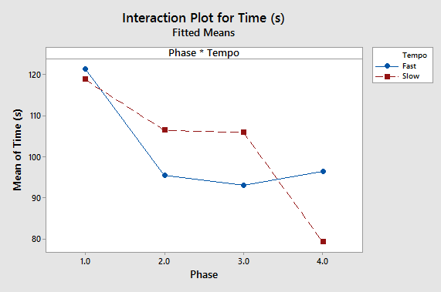

Tukey confidence intervals for phase/type interaction

Tukey intervals for phase/tempo interaction

