Factors Surrounding Prostate Cancer Recurrence

Abstract
This study investigates whether tumor volume affects prostate cancer recurrence and time to cancer recurrence. We analyzed a 2011 retrospective cohort study by Cata et. al which assembled information from 316 prostate cancer cases who underwent radical prostatectomy and received an allogeneic blood transfusion. We analyzed the data to see whether or not there was a relationship between tumor volume and cancer recurrence and time to recurrence. A chi-square test for independence and a t test was performed to test for a relationship between cancer recurrence and tumor volume. Finally, we conducted 95% confidence intervals to determine the true proportion of patients who experienced recurrence among individuals with non-extensive tumors. We found statistically significant evidence of a relationship between cancer recurrence and tumor volume. However we did not find statistically significant evidence that the mean time to cancer recurrence among those who experienced recurrence is related to tumor volume.

Introduction
Prostate cancer is one of the most prominent medical afflictions among men. A common treatment is radical prostatectomy, where doctors remove the prostate from the cancer-stricken patient. However, biochemical recurrence of prostate cancer occurs in some patients after prostatectomy, with about 10% to 30% of patients experiencing recurrence within 5 years of the operation. In this study, we investigate whether tumor volume removed during radical prostatectomy is associated with whether or not the cancer shows biochemical recurrence among men with prostate cancer? Likewise, among those who do experience recurrence, is the tumor volume removed associated with the amount of time it takes for recurrence to occur? We hypothesize that the volume of the tumor removed is associated with prostate cancer recurrence.

Methods
The data come from a 2011 retrospective cohort study by Cata et al., which compiled information on 316 men with prostate cancer that underwent radical prostatectomy and received an allogeneic blood transfusion during the operation or within 30 days. Our explanatory variable is the tumor size removed during prostatectomy (**TVol**), which initially included 3 levels: low, medium and extensive. Moreover, our first response variable is whether or not the patient experienced biochemical cancer recurrence (**Recurrence**). Our response variable is the time in months for biochemical recurrence to occur among patients who experienced recurrence (**TimeToRecurrence**). If the patient did not experience recurrence, the value for the TimeToRecurrence variable is the time it took for the study to end. In order to effectively investigate questions regarding actual recurrence times, we modified the data set by removing the observations from individuals who did not experience cancer recurrence. We also modified our data set by combining the tumor volume categories of “low” and “medium” so that the TVol variable has two levels: extensive and non-extensive. This was chosen due to the small number of patients that had tumors classified as low. Furthermore, since many of our recurrence time distributions were skewed, we added the natural logarithms of these values to generate more normal distributions for inference purposes.

In order to investigate if the volume of the tumor removed during prostatectomy among men with prostate cancer is associated with whether or not the cancer shows recurrence, we generated a mosaic plot of Recurrence vs. TVol and compared the proportions of recurrence in each tumor volume category. We also calculated a chi-square value, a corresponding p-value, and a 95% confidence interval for the true difference in recurrence proportions between the two tumor volume categories via a chi-square test of independence between Recurrence and TVol. Likewise, to investigate whether the volume of the tumor removed is associated with the amount of time it takes for the cancer to show recurrence, we generated a histogram showing the distributions of the log-transformed recurrence times within each tumor volume category, along with a table showing the medians, means and standard deviations of the data within each tumor volume category. We also calculated T-values, corresponding p-values, and 95% confidence intervals for the true differences in means via a t-test for the log-transformed recurrence times vs. tumor volume.

Results
Our research question addresses whether the volume of the tumor removed during prostatectomy is associated with cancer recurrence or cancer recurrence time. The mosaic plot in figure 1 shows how the proportion of cancer recurrence among those who had extensive tumors removed (32.3%) is greater than the proportion of recurrence among those who had non-extensive tumors removed (9.7%), while table 1 shows how the mean recurrence time among those in the extensive tumor group (16.9 months) is less than the mean recurrence time among those in the non-extensive tumor group (23.0 months). The histogram in figure 2 shows that the distributions of log-transformed recurrence times within each tumor volume group are pretty normal.
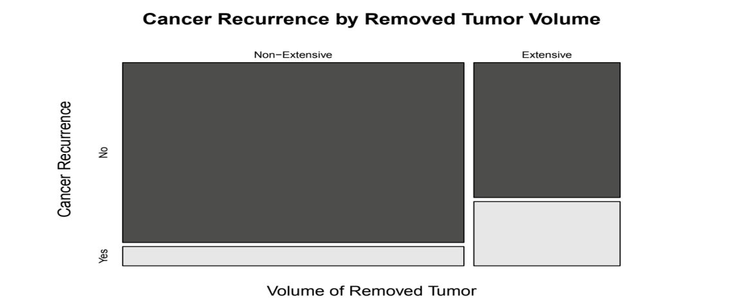 Figure 1: Mosaic plot. Proportion of cancer patients within extensive and non-extensive tumor categories that did or did not display recurrence (Yes or No).
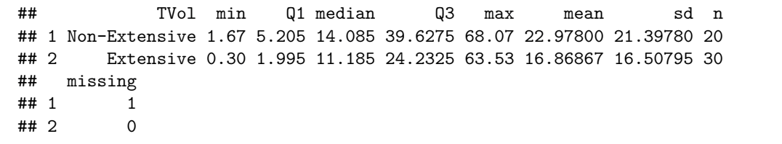 Table 1: Summary Statistics for the time (in months) it took for prostate cancer to recur in each tumor category.
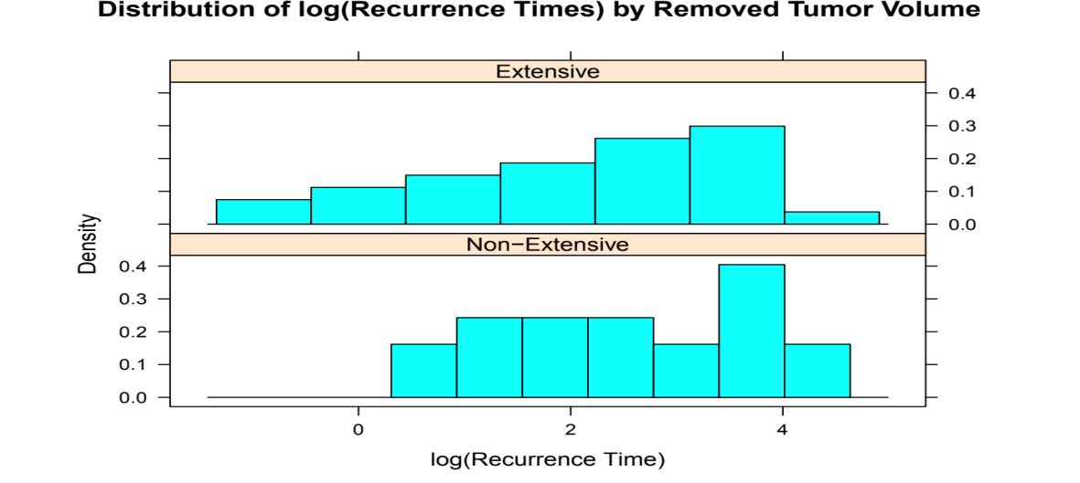 Figure 2: Histogram of the log transformations of the actual times it took for patients to experience recurrence in each tumor volume category (extensive and non-extensive).
In order to test for a relationship between cancer recurrence and tumor volume, conditions were met for a chi-square test of independence between cancer recurrence and tumor volume, which yielded a chi-square value of 24.149 and an associated p-value of less than 0.001. This suggests that the probability of seeing a chi-square value greater than or equal to ours if cancer recurrence and tumor volume are completely independent of one another is extremely low. This chi-square test generated a 95% confidence interval of (-0.3286, -0.1230), indicating that we are 95% confident that the proportion of patients with non-extensive tumors removed who experience recurrence is between 32.86% and 12.30% less than the proportion of patients with extensive tumors removed who experience recurrence.
In our inference to test whether the mean time to recurrence is related to tumor volume, conditions were met (with the possible exception of normality) for performing a t-test for log-transformed recurrence time vs. tumor volume which gave T-values of 1.149 and corresponding p-values of 0.2566. This p-value indicates that the probability of seeing a T-value whose absolute value is greater than or equal to 1.149 are 25.66% if the mean log-transformed recurrence times within each tumor volume group are equivalent.

Discussion
Our chi-squared test of independence for recurrence vs. tumor volume shows statistically significant evidence of a relationship between prostate cancer recurrence and tumor volume. We are 95% confident that the true proportion of patients with non-extensive tumors removed who experienced recurrence is between 32.86% and 12.3% less than the proportion of patients with extensive tumors removed who experienced recurrence. Since our interval does not contain zero, this is consistent with the statistical significance indicated by our hypothesis test. However, we did not find statistically significant evidence that the mean time to cancer recurrence among those who experienced recurrence is related to tumor volume, as neither of our t-tests illustrated a statistically significant relationship between these variables. Research conducted by the Ottawa Regional Cancer Center and Memorial Sloan-Kettering Center investigated cancer recurrence based on the density of the prostate cancer tumor (Lavallée, Luke T. et al). Their results showed that prostate cancer tumor density is independently predictive of recurrence following radical prostatectomy (p= 0.003). This also corresponds to our hypothesis test relating to tumor volume which showed that there was a statistically significant relationship between the size of the tumor and the rate of prostate cancer recurrence. Ultimately, our results provide statistically significant evidence that patients with larger tumor volumes removed during radical prostatectomy could be more likely to experience recurrence.

One study limitation that could affect whether our study can accurately analyze the variables of interest includes limited sampling methods. This study only includes patients at Cleveland Clinic, which may limit our ability to generalize to the overall population. In terms of suggestions for future research, it would be advisable to create a more representative dataset that samples a wider variety and larger sample size of prostate cancer patients. One way that researchers could sample a wider variety of patients is by taking samples from more hospitals from wide variety of regions. This would allow for a more representative study with a wider representation of prostate cancer cases. More research should also be conducted to further investigate our finding that patients with larger tumor volumes removed during radical prostatectomy could be more likely to experience recurrence since this has significant impact upon patient prognosis following radical prostatectomy.

References
Amy S. Nowacki, “Blood Storage Dataset”, TSHS Resources Portal (2017). Available at https://www. causeweb.org/tshs/blood-storage/.
Atzil, S., Arad, M., Glasner, A., Abiri, N., Avraham, R., Greenfeld, K.,Rosenne, E., Beilin, B., BenEliyahu, S. (2009). Blood Transfusion Promotes Cancer Progression: A Critical Role for Aged Erythrocytes. Anesthesiology, pp 989-997.
Carter, S., Bob, Bova, G., Steven (1993). Hereditary Prostate Cancer: Epidemiologic and Clinical Features. The Journal of Urology, pp 797-802.
Cata et al. “Blood Storage Duration and Biochemical Recurrence of Cancer after Radical Prostatectomy”. Mayo Clin Proc 2011; 86(2): 120-127.
Lavallée, Luke T., et al. “The Association between Tumour Density and Prostate Cancer Recurrence Following Radical Prostatectomy.” Canadian Urological Association Journal, Canadian Medical Association, Dec. 2011.

