Effect of Legal and Legislative Provisions on Burden Indicators of Substance Use Disorders in European Countries

Abstract
Research suggests that punishment has limited impact on illicit substance use, and in an attempt to alleviate the burden of substance use disorders in a way that reduces incarceration, a variety of alternative measures have been developed. Difference in means analysis was used to examine the relationship between the existence of legal and legislative provisions for treatment and prevention and indicators of the burden of disease for drug and alcohol use disorders in 53 European countries. Analysis identified trends of improvement in burden indicators in countries that have implemented legislative provisions for prevention and treatment of substance use disorders, most notably countries with provisions for treatment and rehabilitation, which showed a significant reduction in death rates due to substance use disorders (p-value<.01). These findings support further implementation of legislative provisions in an effort to effectively curb the burden of substance use disorders within communities.

Introduction
Implementation of the ‘war on drugs’ has resulted in the prosecution of drug offenses in many countries and lengthy sentences for individuals involved in the trafficking, use, and possession of narcotics. Research suggests that punishment has a limited impact on illicit drug use, and countries that impose severe penalties for possession and personal consumption of drugs are no more likely to deter drug use in the community than countries imposing less severe sanctions (Penal Reform International 2015). A variety of alternatives to imprisonment have been developed to better attend to offenders who have problems with drug dependency. Drug court systems divert non-violent offenders away from incarceration and into highly structured addiction treatment programs, have addressed addiction in a manner that is demonstrably more effective than simple incarceration of the addict (Westreich 2015), and involve community-based treatment and monitoring of participant’s progress by the judge (Johnson 2000). Other alternatives include treatment and rehabilitation provisions in mental health legislation, compulsory treatment for individuals with substance use disorders who come into contact with the criminal justice system, and a line in the annual federal budget to provide financial means for development, maintenance, and strengthening of prevention activities and services.
Understanding the impact of these provisions is critical to promoting the development of treatment and prevention programs that effectively reduce the burden of drug use disorders in communities around the world. This project will explore the effectiveness of different legislative provisions in lessening the burden of substance use disorders in European countries. We hypothesize that countries that have implemented one or more of these programs will show indications of reduced burden of alcohol and drug use disorders: lower point prevalence, lower death rates, and fewer disability-adjusted life years lost due to substance use disorders.
Materials and Methods
The dastaset used for this analysis was obtained from the World Health Organization (WHO) Global Health Observatory Data Repository resources for substance use disorders, European region. The WHO prepares and publishes estimates for different health indicators as part of a Global Burden of Disease study to quantify the burden of disease in a manner that is consistent and comparable between countries. Treatment and prevention provisions explored in this study include the presence of a drug court system, a legislative provision for compulsory treatment, a legislative provision for treatment and rehabilitation, and a budget line for substance use disorder prevention in each of 53 measured countries in 2008. Burden indicators include the point prevalence of substance use disorders (proportion of the population 15 years or older who suffer from substance use disorders), age-standardized death rates (number of deaths per year per 100,000 individuals in the total population due to alcohol or drug use disorders), and disability-adjusted life years lost (DALY). DALY is defined as the sum of the life years lost due to the burden of alcohol/drug use disorders per 100,000 individuals in the population. One DALY can be thought of as one lost year of “healthy” life. Point prevalence values used are from 2004, and the death rate and DALY values are from 2008. These values are being used under the assumption that the prevalence of drug and alcohol abuse stayed relatively stable within each respective country for the 4-year span between 2004 and 2008.
The differences in mean burden indicators for countries with and without these provisions were explored. The total dataset was filtered so that all cases with missing information for either of the variables being tested for were removed from the set. Variables for death rates from alcohol and drug use disorders were merged and DALY variables for drug and alcohol use disorders were merged to create two new variables representing the total death rate and total DALY for substance abuse disorders. A new variable, “NumExpl,” was created to explore the relationship between the number of treatment and prevention provisions present in a country and indicators for burden of substance use disorders. This variable divided our cases into categories based on how many of the legislative provisions each country has implemented (0,1,2, or 3). To explore if burden indicators improved with the presence of legislative provisions, the means for all of the response variables in terms of each of the explanatory variables were calculated. Welch two variable t-tests were performed on each of the explanatory and response variable pairs to determine the significance of the difference in the means of the response variables between countries with and without the prevention or treatment programs. P-values and 95% confidence intervals were found for the means between each of the pairings.
Results
Analysis did identify trends of improvement in burden indicators in countries that have implemented legislative provisions for prevention and treatment of substance use disorders. Out of 24 pairs of explanatory and response variables, 14 showed that indicators of drug and alcohol burden were, on average, lower in countries that had judicial or legislative provisions aimed toward curbing the burden of alcohol and drug use disorders. For example, out of 41 countries, those with a compulsory treatment provision averaged a point prevalence of drug use in females of 0.163 in 2004, while countries without this provision averaged a point prevalence of 0.225, as demonstrated in Figure 1. Two additional cases of improvement in mean burden indicators in countries that implemented legislative provisions can be found in Figures 2 and 3.
Only 3 explanatory and response variable pairs were found to have statistically significant differences in means. There is statistically significant evidence (t= -2.18, p-value= 0.035) that the mean death rate due to drug use disorder is lower in countries with provisions for treatment and rehabilitation than it is in countries without (Table 1). We are 95% confident that the mean death rate due to drug use disorders in countries with provisions for treatment and rehabilitation is between 1.13 and 0.04 deaths fewer per 100,000 individuals than in countries without. Additionally, there is statistically significant evidence (t=2.065, p-value=.048) that the mean death rate due to drug use disorders in countries with a budget line for substance use disorder prevention is lower than it is in countries without (Table 2), and that the mean death rate due to alcohol use disorders in countries with provisions for treatment and rehabilitation is lower than it is in countries without (t=-4.04, p-value< 0.001) (Table 3).
Exploration of the relationship between explanatory variables and the merged totals for death rates revealed statistically significant evidence (t=-4.2, p-value <0.001) that the mean total death rate in countries with a legislative provision (4.08 per 100,000) for treatment and rehabilitation is actually higher than it is in countries without these provisions (1.83 per 100,000) (Figure 4). We are 95% confident that the mean total death rate due to substance use disorders in countries with legislative provisions for treatment and rehabilitation is between 3.3 and 1.2 deaths per 100,000 greater than the mean total death rate due to substance use disorders in countries lacking these provisions. Countries that have implemented a federal budget line for funding substance abuse prevention and treatment had a generally lower mean total DALY value (602.6 life years lost) than did countries lacking this budget line (718.1 life years lost). While the difference in these means is not significant (t=1.16, p-value= 0.25), the general trend is clear and demonstrated in Figure 5 shown below. We did not observe that countries with more legislative provisions present showed improvement in average total life years lost or total death rate due to substance use disorders than did countries with fewer provisions in place. The relationship between number of indicators implemented and average total DALY and death rate are shown in Figure 6 and Figure 7, respectively.
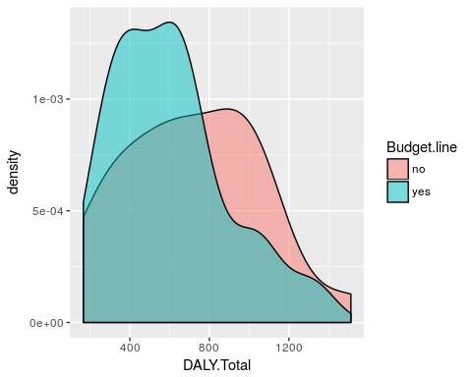
Figure 5. Effect of presence of budget line for prevention of substance use disorders on mean total disability-adjusted life years lost due to substance use disorders.
Discussion
As hypothesized, this analysis revealed a general trend that countries with certain legislative provisions in place for the prevention and treatment of substance use disorders show general improvements in burden of disease indicators including death rate, disability-adjusted life years lost, and point prevalence of substance use disorders. 14 out of 24 variable pairs tested showed that indicators of drug and alcohol burden were, on average, lower in countries that had judicial or legislative provisions aimed toward curbing the burden of alcohol and drug use disorders, and countries that had implemented legislative provisions for treatment and rehabilitation showed improvement in total DALY. These findings are consistent with the claim articulated by Chandler et al. that treatment of drug addiction, especially in conjunction with the criminal justice system through systems like drug courts, provides a unique opportunity to intervene and disrupt the cycle of drug use in a cost-effective manner (Chandler et al. 2017), and suggest that more European governments should consider introducing this provision in order to reduce the burden of drug use disorders within their countries.
The results produced through this analysis are not generalizable worldwide due to the fact that the sample was fairly small (53 countries) and composed of only European countries. We are not able to draw any causal conclusions from this analysis due to the fact that the dataset was collected through a retrospective observational study rather than through a designed experiment. While we can observe general trends, we cannot claim that the presence of these legislative provisions is the cause of improvement in different burden indicators. Possible future studies could incorporate similar methods but include a larger, more representative random sample of countries from around the world in order to make more generalizable conclusions. Further research could look at differences between programs of various countries to see which particular factors differentiated the more effective programs from the less effective programs, or compare indicator values before and after implementation of programs. This research found that countries that have implemented different legislative provisions for treating and preventing substance use disorder show improvement in burden of disease indicators over countries that have not implemented these provisions, and supports further implementation of preventative practices in an effort to effectively curb the burden of drug use disorders within communities.
References
Chandler, Redonna K., Bennett W. Fletcher, and Nora D. Volkow. “Treating Drug Abuse and Addiction in the Criminal Justice System: Improving Public Health and Safety.” JAMA: the journal of the American Medical Association301.2 (2009): 183–190. PMC. Web. 10 Dec. 2017.
Johnson, S., Dana, J. H., & Latessa, E. J. (2000). Drug courts and treatment: Lessons to be learned from the "what works" literature. Corrections Management Quarterly, 4(4), 70. Retrieved from https://search.proquest.com/docview/214563903?accountid=351
Penal Reform International. Global Prison Trends 2015: Drugs and Imprisonment. Global Prison Trends 2015: Drugs and Imprisonment, 2015.
Westreich, Laurence. (2015). Medication-assisted treatment and drug courts. Psychiatric Times, 32(11), 25. Retrieved from http://go.galegroup.com/ps/retrieve.do?tabID=T002&resultListType=RESULT_LIST&searchResultsType=SingleTab&searchType=AdvancedSearchForm&currentPosition=1&docId=GALE%7CA434135392&docType=Article&sort=RELEVANCE&contentSegment=&prodId=EAIM&contentSet=GALE%7CA434135392&searchId=R1&userGroupName=mnastolaf&inPS=true

Appendix
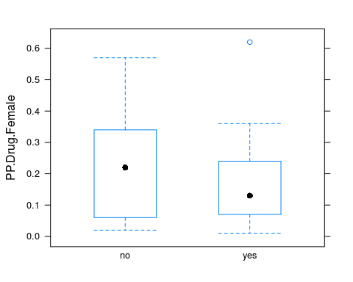
Figure 1. Effect of presence of legislative provision for compulsory treatment on point prevalence of drug use disorders in females.
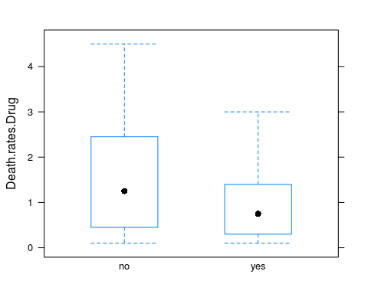
Figure 2. Effect of presence of budget line for the prevention of substance use disorders in annual budget on death rates due to drug use disorders per year per 100,000 individuals.
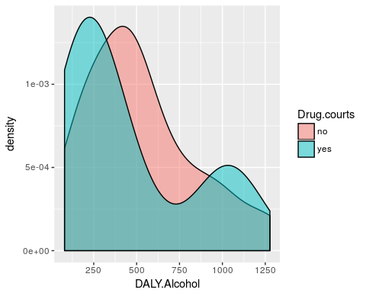
Figure 3. Effect of drug court system on disability adjusted life years due to alcohol use disorders per year per 100,000 individuals.
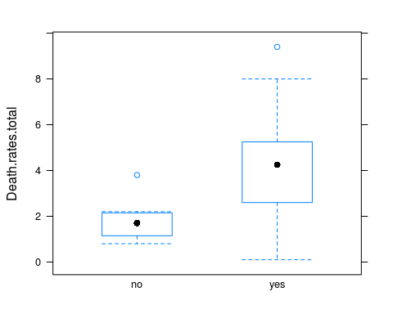
Figure 4. Effect of presence of legislative provision for treatment and rehabilitation on mean total death rate due to substance use disorders.
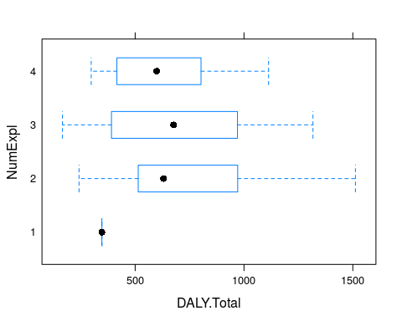
Figure 6. Effect of number of explanatory variables present on mean total disability-adjusted life years lost due to substance use disorders. Labels on y-axis (1,2,3,and 4) represent countries with 0,1,2,and 3 provisions present, respectively. Low total DALY value observed for countries with no provisions is likely due to the fact that there were only 2 cases in this category.
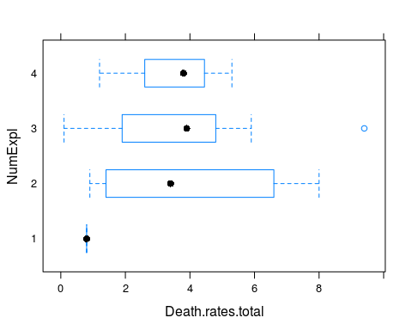
Figure 7. Effect of number of explanatory variables present on mean total death rate due to substance use disorders. Labels on y-axis (1,2,3, and 4) represent countries with 0,1,2,and 3 provisions present, respectively. Low total death rate value observed for countries with no provisions is likely due to the fact that there were only 2 cases in this category.
Table 1. Summary statistics for the effect of legislative provision for legislative provisions for treatment and rehabilitation on death rates due to drug use disorders per 100,000.
## Treatment.and.rehabilitation min Q1 median Q3 max mean sd
## 1 no 0.1 0.5 0.7 1.0 1.5 0.7777778 0.4437842
## 2 yes 0.1 0.4 1.0 2.2 4.5 1.3620690 1.1983363
## n missing
## 1 9 2
## 2 29 3

Table 2. Summary statistics for the effect of budget line for the prevention of substance use disorders in annual budget on death rates due to drug use disorders per 100,000.
## Budget.line min Q1 median Q3 max mean sd n missing
## 1 no 0.1 0.475 1.25 2.375 4.5 1.6450000 1.3990504 20 2
## 2 yes 0.1 0.350 0.75 1.400 3.0 0.9055556 0.7384182 18 3

Table 3. Summary statistics for the effect of legislative provision for legislative provisions for treatment and rehabilitation on death rates due to alcohol use disorders per 100,000.
## Treatment.and.rehabilitation min Q1 median Q3 max mean
## 1 no 0 0.300 1.3 1.700 2.9 1.177778
## 2 yes 0 0.725 2.8 3.575 8.8 2.506667
## sd n missing
## 1 0.9483904 9 2
## 2 2.0673043 30 2

Table 4. Summary statistics for the effect of legislative provision for legislative provisions for treatment and rehabilitation on death rates due to substance use disorders per 100,000.
## Treatment.and.rehabilitation min Q1 median Q3 max mean sd
## 1 no 0.8 1.3 1.90 2.200 3.8 1.955556 0.9658042
## 2 yes 0.1 2.8 4.25 5.225 9.4 4.078571 2.1944977
## n missing
## 1 9 2
## 2 28 4

