Instructions to create your own iPod playlist simulation in Fathom.
1) Drag and drop a collection icon from the shelf. An icon with gold marbles should appear on your workspace.
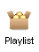
2) To import your own playlist either
a) choose File Import fileImport from File. For this option your playlist must be saved as a tab delimited .txt file with the variable names at the top.
OR
b) Copy and paste your playlist into an excel (or other) spreadsheet. Put variable names above each column. Highlight and copy the columns out of the spreadsheet. Go back to Fathom, click on Collection 1 and paste.
3) When you are done copying over your playlist, click and highlight the collection icon. Under the Object menu, select Inspect Collection. A new window should appear such as below:
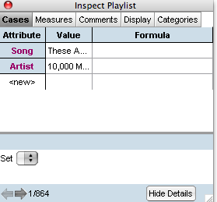
Under attribute you should see your variable names. Next to that, under Value, you should see the first song in your playlist.
4) In the menu bar, under the Collection menu, select Sample Cases. A new collection icon should appear with blue marbles on your workspace.
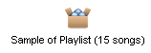

Click on this new icon and then in the menu bar, select Inspect Collection under the Object menu. A window should appear like the one below.
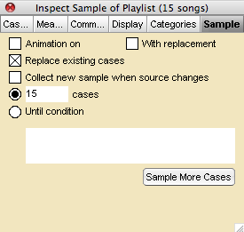
If not already selected, click on the sample tab in this new window. Uncheck the With replacement box and change the number of cases to the number of songs you wish to sample each time. (In my example, I have set this to 15) Click sample more cases. This creates a single playlist.
Next, click on the Cases tab (far left) in the sample collection icon (the one you currently have open). You will see the first song that was selected in the sample and you can use the arrows at the bottom left corner of the window to scroll through the playlist.
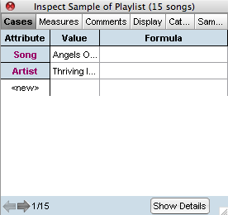
5) To open a table to see the list of 15 songs that were selected, make sure the sample collection icon is still highlighted by clicking on the blue marbles icon in your workspace. The drag and drop a table onto your workspace from the shelf. A table should appear that shows your randomly selected playlist in order.
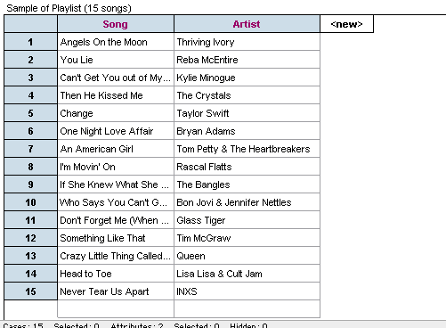

6) To create a bar chart of the artists, drag and drop a graph icon from the shelf onto your workspace. A window will open that is mostly blank. From either the table or the inspection window of your sample, drag the attribute “artist” and drop it somewhere in this new graph window. The bar chart should appear.
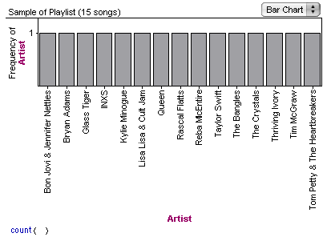
7) You can go back and select fresh samples of 15 songs one at a time by going back to the inspection window of the sample and clicking on the sample tab (far right). Select sample more cases and be sure to check the Replace existing cases box. The bar chart and the table will automatically update with your new playlist.
8) To define a variable that will count the number of playlists that either contain a repeated artist or don’t, select the measures tab in the sample icon inspection window.
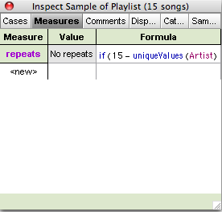
Under the measure column, type in a name for your variable (I used repeats). Then, under the Formula column, double click. A new formula window should appear. Type in the following formula:

As you start typing the formula, it will automatically take on the correct format. Notice the above formula assumes a 15 song playlist. If you wish to change this, change the 15 in the above formula to your chosen n. Click ok.
9) In order to set up the simulation of 1000 playlists, highlight the sample icon (with the blue marbles) again and under the Collection menu, select Collect Measures. A third measures icon (with green marbles) should appear on the workspace.
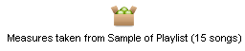
Highlight and inspect this new measures icon.
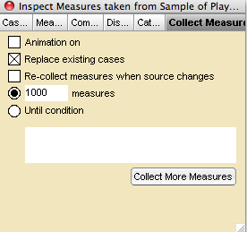
Uncheck the Animation box. Check the Replace existing cases box and set the measures to 1000. Click the Collect More Measures button. This may take a minute and you may get a progress bar. As this is happening, you will see the bar chart and the table of the playlists updating occasionally.
10) To create graph of your repeats measure, click the cases tab in this green Measures icon inspector window (shown in #9 above). Drag and drop a graph from the shelf onto the workspace. Drag and drop the attribute repeats (or whatever you have named it) from the Measures inspector window onto this new graph window and a graph similar to the one below should appear.
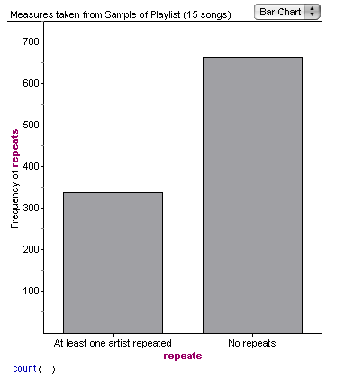
You can also create a ribbon chart that shows the percentages. Click on the drop down button in the upper right corner and select Ribbon Chart.
