Requirements and Grades

For this course, we are going to use an alternative grading concept called “ungrading.” This is likely different than most other courses you have taken. Instead of receiving points, percentages, and grades for assessments (e.g., homework, projects), you will instead only receive feedback. You are encouraged to resubmit (deadlines will be announced) assessments until you are satisfied with the result or have mastered the concepts. We will discuss this grading policy on the first day of class, during which I am happy to answer any questions or concerns you have.

You will still receive a typical final grade for the course (A, A-, B+, B, …), but YOU will be responsible for helping me evaluate your progress and what grade you have earned for the course. One goal for the course is for you to develop the ability to accurately self-assess. This is an important life skill – you should rarely be surprised in performance reviews if you have a good understanding of what you have been doing. I will help you through this by providing feedback and in individual meetings. Note: although you will help me evaluate your progress, I reserve the right to modify the final grade based on my observations.

I understand that this may cause some uncertainty or anxiety in some of you. You should know that it’s ok! At any point during the course, if you are feeling uncertain or anxious, please come talk to me. I’m more than happy to discuss where you are at.

There will be two points during the semester (before I submit mid-semester grades and at the end of the semester) during which I will meet with each of you to provide feedback on how you are doing. You will complete a self-assessment and reflection before we meet. During the meeting, we will discuss where you are at in the course, how well you are doing, and what you should do to finish the course.

Requirements and Grades Section 1: Assessment Types

Throughout the course, there will be a variety of opportunities for you to learn material and show that you have mastered the core course concepts. Each assessment type (e.g., homework, projects) will allow you to demonstrate a different type of learning (more on this below). Here are the general types of assessments in the course:

Participation and Attendance

Learning statistics requires a lot of practice and engagement. I expect that you engage in opportunities to hone your skills and think about how to apply those skills to your area of interest. Though this is typically done through in-class participation, there are many other avenues. For example, attending tutoring sessions or coming to drop-in hours are great ways to engage in the course content.

Class sessions are a vital component of the course where we will introduce concepts and learn together by working through examples and activities. You are expected to attend and actively participate in all classes. This also includes completing out-of-class work on time, e.g., readings, assessments.

If you are unable to attend class, filled-in lecture notes will be available. I strongly recommend meeting with a classmate to discuss what you missed. After you review the notes and discuss with a classmate, please feel free to meet with me (or a tutor) to cover the concepts you are unsure about.

Finally, extraordinary circumstances may arise for some of you during the semester. You may find yourself facing more than you can handle, making it difficult to focus on this course. First, Elon’s Counseling Services provides support for students going through such problems, and I encourage you to seek their help if needed. Second, I try to be flexible with these disruptions and, on a case-by-case basis, may provide additional time to complete assignments. However, I must know something is going on to help. Please contact me as soon as you can; I don’t need details – just a message that life has become difficult or complex and some idea of what this means for the course.

Knowledge Checks and Homework

Knowledge Checks (KCs) are weekly Moodle-based quizzes that provide an opportunity for you to check your understanding of the material. You will have unlimited attempts to complete KCs (up to the deadline). There will be around 12 KCs throughout the course.

Homework will involve higher level knowledge relative to KCs, as you will need to apply concepts to new questions. There will be around 8 homework assignments throughout the course. For each homework, I will provide feedback and give you either a “Conditional Accept” (CA) or “Revise and Resubmit” (RR). The CA/RR designation is not a grade; it is simply a very broad-scale indicator of whether there are questions that you can revise and improve. You are allowed 2 resubmissions per homework assignment to incorporate any feedback I give you. Resubmissions show me that you are (a) putting in effort into the course and (b) that you are learning from your mistakes. Though resubmissions are optional, they are the best way to show that you understand what you did incorrectly.

Deadlines for KCs and homework will be posted on Moodle, so make sure to regularly check for submission details.

Projects

Projects are the capstone assessment for the course. They will involve synthesizing information that you’ve learned throughout the semester and will require you to apply your knowledge to new, less-structured settings. There will be 2 group projects during the course. Each project will have multiple components, including drafts that will be submitted early in the process.

Reflections

A core component of the “ungrading” system is self-evaluation and reflection. Several times throughout the semester, I will have reflection assignments. It is important that you take these seriously, think through the prompts, and give thoughtful, complete responses. Your reflections are your opportunity to explain what you have learned, what is important to you, and what you still believe you can work on.

Requirements and Grades Section 2: Assessments and Learning

There has been a lot of research into how people learn. One popular model is Bloom’s taxonomy (Figure 1), which breaks apart types of learning.

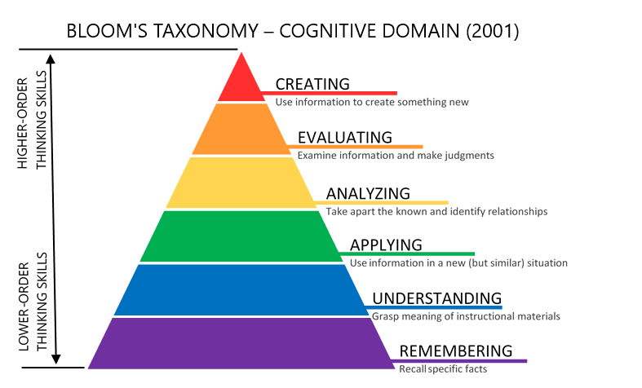
Figure 1. Bloom's Taxonomy Diagram. Image from https://citt.ufl.edu/resources/the-learning-process/designing-the-learning-experience/blooms-taxonomy/.

Different components and assessments in this course will contribute to different areas in Bloom’s taxonomy:
- KCs and in-class review questions will primarily assess lower-order thinking skills (remembering and understanding)
- Homework and in-class activities will primarily assess mid-order thinking skills (analyzing and applying)
- Projects and some homework questions will assess higher-order thinking skills (creating and evaluating)
You should care about all levels in this taxonomy. You can’t create new information without being able to analyze and apply existing information. You can’t analyze and apply information if you don’t understand or remember the basic principles.

Requirements and Grades Section 3: Putting It All Together

Each of you will have different goals for this course. This likely includes both knowledge you want to gain and a preferred grade you would like to achieve. Your final grade will only be assigned after an individual discussion with me, during which we will discuss your progress and where you will provide evidence of your learning.
For STS 2120, there are two broad categories to consider when evaluating yourself: effort and content. “Effort” encompasses how much work you put into the course – e.g., completing assignments on time, actively engaging in the course, resubmitting assignments. “Content” refers to the statistical content you learned and your ability to implement the techniques correctly. For content, you should refer to the course learning outcomes, course learning objectives, and Bloom’s taxonomy (see previous sections).

Note: It will be hard to justify a good grade for the course if you continuously turn work in late or rarely attend class. If there are special circumstances, such as a serious illness, please let me know and we can make alternative arrangements.

General criteria for different grade ranges are shown below. Note: I do not believe you should aim for a grade lower than a C, which is why I only put A, B, and C on the chart. However, grades lower than C will be given if work does not meet the general standards.

Grade | Content | Effort
A | - Exhibits high level (1) understanding of core concepts and terms, (2) ability to analyze and apply those concepts, and (3) ability to evaluate and create new information  - Meets learning outcomes and objectives fully/consistently  - Consistently shows evidence of growth, turning weaknesses into strengths | - Completes all assignments  - Submits nearly all (at most 2 late) assignments (KCs, HW, projects, resubmissions) on time  - Consistently completes resubmissions  - Consistently engages in the course material, both in and out of class
B | - Exhibits high level (1) understanding of core concepts and terms and (2) ability to analyze and apply those concepts. (3) Ability to evaluate and create new information is less developed.  - Meets learning outcomes and most learning objectives fully/consistently  - Regularly shows evidence of growth | - Completes nearly all (at most 2 missing) assignments  - Submits most assignments on time (at most 4 late)  - Completes resubmissions for most assignments  - Regularly engages in the course material, both in and out of class
C | - Exhibits high level (1) understanding of core concepts and terms. (2) Ability to analyze and apply those concepts and (3) to evaluate and create new information is less developed.  - Meets learning outcomes and only some learning objectives fully/consistently  - Shows some evidence of growth | - Completes most assignments  - Submits most assignments on time  - Occasionally completes resubmissions  - Engages in the course material, but perhaps only regularly either in or out of class
* Some of the above material on “ungrading” are modifications from the following sources: “Ungrading: Why Rating Students Undermines Learning (and What to Do Instead)” edited by Susan D. Blum; Heather Mitchell-Buck’s website and posts

