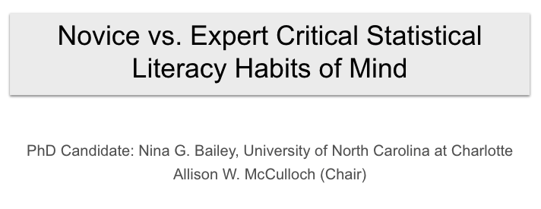
Presentation:
https://docs.google.com/presentation/d/1aKDEsscS5cf9q9XEaJO4n2CtpjSFbrI9g69OvBy7b78/edit?usp=sharing

CSLHM: https://docs.google.com/document/d/18WkLu9zmi47AYy17AjZCjcYLnObqs_JVhd0v2wbilWE/copy?usp=sharing

Data Visualization: https://youtu.be/v0A5rZwc6Wo

Transcript: https://docs.google.com/document/d/1H4Imq38Yn_l4idH43MITKR7UwzgtPzsOVDLE4gN__LM/copy?usp=sharing

Expert Jamboard
https://jamboard.google.com/d/1CYsgUjsZ5xiEXNUEBE9izaZ67TJTx1foz3uU7sR4PX4/edit?usp=sharing

Recognition of One's Own Sociopolitical/Critical Consciousness
https://jamboard.google.com/d/1r8GuxMu-VX88hnuX1bsBQg1Vcs5U82jLbwqQnFJ8aMw/edit?usp=sharing

