Dear workshop participant,
Thanks for signing up to join us on May 22 for a 2-hour workshop about “Teaching the Statistical Investigation Process with Randomization-based Inference.” We’re excited to share our thinking about how to center your course around randomization and simulation while focusing on the statistical process as a whole. As time allows prior to the workshop you may wish to consider the following ‘pre-workshop’ activities:
- Read the preface to the textbook we are writing which provides an overview of our thinking about randomization curricula and our approach in particular. The preface is attached.
- Consider test-driving two web-applets we will be using during the workshop. Instructions for the applets are attached.
- We strongly encourage all workshop participants to complete a short ‘pre-workshop’ survey that will help us to get to know you a bit better. Go here to take the survey: https://www.surveymonkey.com/s/WCM6HMJ. The survey includes an opportunity to indicate any existing questions you have, to report your goals/expectations and whether or not you have any experience with randomization-simulation in your class already. **Note: There are no ‘correct’ answers here and we expect a great deal of diversity in your responses! We will compile the list of questions, and provide responses during or shortly after the workshop. You will also be able to ask questions during the workshop. Providing any questions to us ahead of time, as well as a sense of your goals/expectations will help us to tailor workshop content appropriately and ensure that your questions receives a response and we do the best we can to achieve the goals for as many participants as possible.
- This workshop is an abbreviated version of a longer workshop that we will be offering in a face-to-face format at numerous other venues around the country this summer. If you are interested see http://math.hope.edu/isi for a full listing.
Looking forward to talking with you on May 22,
Nathan Tintle and Beth Chance
Workshop presenters
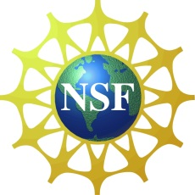
This project has been and is being supported from the National Science Foundation (Grant DUE-1140629) and (Grant DUE-1323210)

