Guidelines for Assessment and Instruction in Statistics Education: College Report

Endorsed by American Statistical Association
July 2016

Birds of a Feather Lunch, USCOTS 2019
Beverly L. Wood woodb14@erau.edu
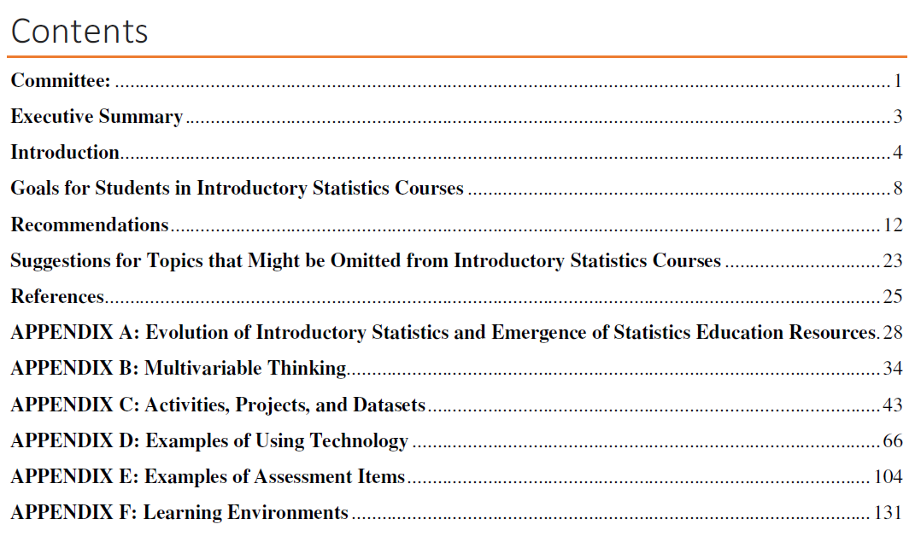

Six Recommendations for Teaching
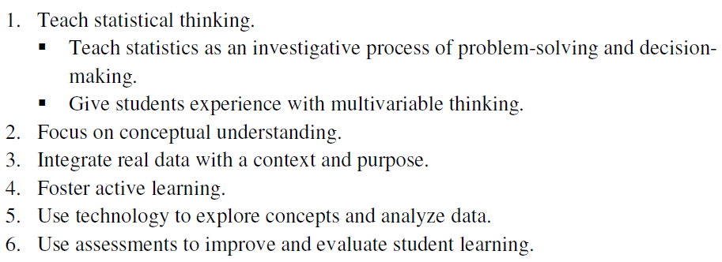
Nine Goals for Students
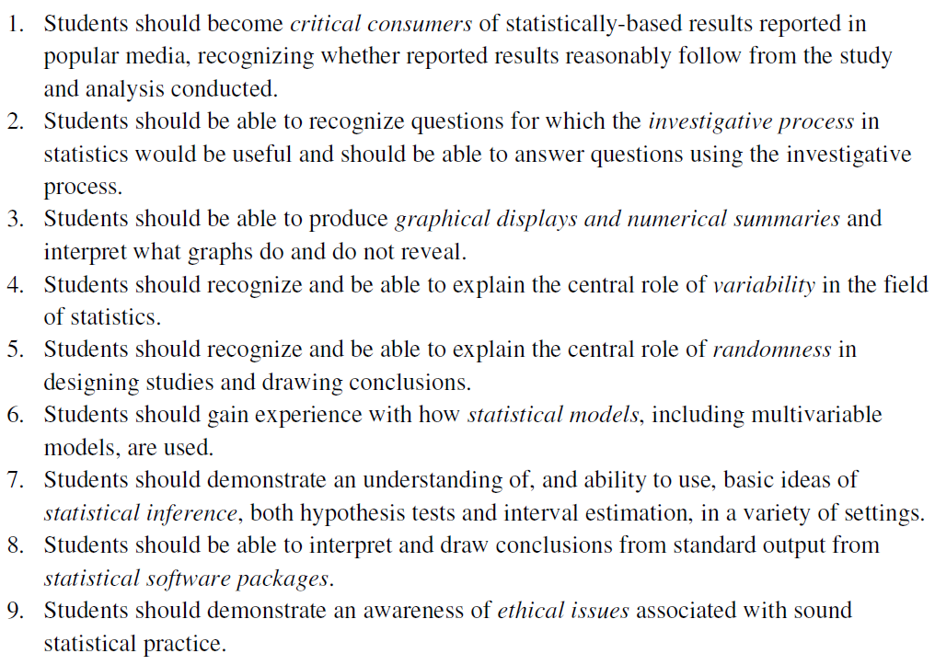

Notes from lunch conversation:
Attendees included two community college instructors and three teacher educators; all eight of us teach service courses (no students majoring in statistics). About even split between knowing GAISE second-hand (through textbook preface, course coordinators, or other colleagues) and first-hand. One instructor with no knowledge of the original version of the college report.
After the personal introductions, Beverly gave an overview of the differences between the original and 2016 documents and some context for the changes. Various commentary about the nature of these changes (generally seen as improvement or modernization) that led to detailed discussion of the need for professional development opportunities for implementing the recommendations for teaching.
Several existing, related resources were discussed and others proposed:
- Hollylynne Lee (NC State Univ) asked the table about the possibility of revising/duplicating The Friday Institute MOOC “Teaching Statistics Through Inferential Reasoning” that was developed around the GAISE Report for K-12. (https://place.fi.ncsu.edu/local/catalog/course.php?id=11&ref=1)
- StatWay (https://carnegiemathpathways.org/statway/)
- edX MOOC on Evidence-based teaching https://www.edx.org/course/an-introduction-to-evidence-based-undergraduate-stem-teaching)
- BuildMathMinds.org by Christina Tondevold, recorded professional development for K-8 teaching that is useful even for college teaching with active learning.

