Coin Ages Activity – Part I

Overview: We will simulate in Fathom what we did in the Coin Ages Activity.
- We will take a sample of size n=5 (with replacement), calculate the mean age of the sample, plot the mean and repeat this process 100 times.
- We will then repeat this process for samples of size n=10, n=25 and n=50. We will use a slider to control the sample size.

Fathom Instructions:

- Open the file: Coin Ages 03.ftm.
- Drag the age attribute to the graph in the upper right of your screen and drop it on the x-axis.

- Change the graph to a histogram by clicking on the triangle in the upper right hand corner of the graph window.
- The mean age of the pennies is 12.264 and the standard deviation is 9.913. Sketch a graph of the histogram below. (Put your mouse over a bar in the histogram until it changes to a hand. The status bar in the lower left hand corner of your screen will display the interval and the number of cases in the interval).

- Would a Normal distribution be an appropriate model for the ages of coins in circulation graph? Justify your answer.

- The sample size is set to n=5. Click on the button, Sample More Cases to take a sample of 5 pennies.

- As we did in our hands-on activity, we want to calculate the mean of our sample of 5 pennies and graph this mean on a dotplot. We will then replace our sample and take another random sample of 5 pennies, calculate the mean, graph the value on our dotplot, and repeat the process until we have collected 100 means from samples of 5 pennies (taken with replacement) from our collection of pennies. The dotplot will represent the sampling distribution of sample means of size n=5 of penny ages in our collection.

- Once we click on the button to have Fathom carry out the above operations, several things will be happening at once, so it is important to take a moment beforehand to make sure that you understand what is happening. Below is a graphic after taking three samples of size n= 5 with replacement. Here are a few things to note as the animation is taking place:
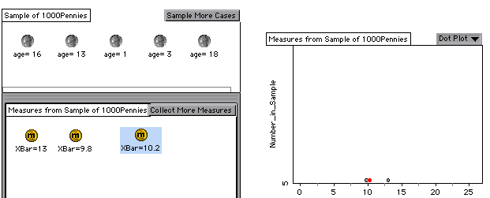
  - The value of each coin in the sample changes to reflect each new random sample of 5 pennies.
  - The mean (x-bar) of each new sample of 5 pennies is recorded in the measures collection below the sample.
  - Each new mean (x-bar) is plotted on the dotplot to the right of the sample.

- Okay you are ready to go! Click on the Collect More Measures button.

Note: I left the animation feature on so that you could see the sampling distribution being created..

- The summary table at the bottom of the screen gives the mean and standard deviation for the given sample size. Record the mean and standard deviation for sample means of size n=5 and also describe the shape of the distribution.

- Now we will have Fathom take samples of size n=10, calculate the mean age of each sample and plot the mean. We will take 100 samples of size n=10 (with replacement).

It would probably be a good idea at this point to take the animation off to speed things up. To accomplish this you need to uncheck the animation feature in both the sample collection and the measures collection.

Place your mouse anywhere inside the sample collection and double click to bring up the inspector. Click on the Sample tab on the far right and uncheck the box next to Animation on.
You must also repeat this process with the measures collection. After opening the inspector for the measures collection, click on the Collect Measures tab and uncheck Animation on. Close both inspectors.

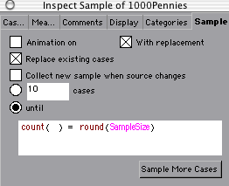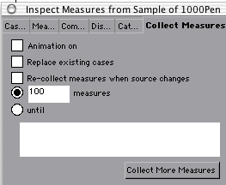

- To change the sample size to n=10, double click on the number 5 on the SampleSize slider or drag the slider to 10 (or a number close to 10 since it is set to round the value). Make sure to hit the return key after changing the value on the slider.

- Click on the button, Sample More Cases to take a sample of 10 pennies.

- Click on the Collect More Measures button again to have
Fathom take 100 samples of size n=10 and to record the mean of each sample. Record the mean and standard deviation (from the summary table – bottom left) for sample means of size n=10 and also describe the shape of the distribution.

- Change the SampleSize slider to 25 (don’t forget to hit return). Click on the button, Sample More Cases to take a sample of 25 pennies then click on the Collect More Measures button. Record the mean and standard deviation for sample means of size n=25 and also describe the shape of the distribution.

- Change the SampleSize slider to 50 and repeat the above steps. Record the mean and standard deviation for sample means of size n=50 and also describe the shape of the distribution.

- Describe the similarities and differences of the four graphs (n=5, 10, 25 and 50) and the graph of the entire collection of pennies. Make sure to address center, shape and spread.

- Look up Central Limit Theorem (CLT) in your text and write a few sentences about how this activity relates to the CLT.

- To put a normal density curve on the graphs, first change the graph to a histogram. From the graph menu choose Plot Function. Click on the triangle to the left of Functions, then the triangle to the left of Distributions, then the triangle to the left of Normal. Choose normalDensity by double clicking on it and type the following in the parentheses: (x_bar, mean(x_bar), s(x_bar)). The expression should look like the window below.

In the Graph menu select scale and density to rescale the axes.

- Fill in the information for the center, spread and shape of the distribution of sample means for the various sample sizes from your simulation in the table below.

Population Population
Population Mean std dev. Shape
skewed right
Sample  Size | Mean () of  Sample Means | Std. Dev. (s) of  Sample Means | Shape of  Sample Means
1 | 12.264 | 9.613 | Skewed right

5

10

25

50

- The standard deviation of the sample means varies with the size of the sample according to the rule . Are the values in the table for the sample standard deviation calculated by the computer and those calculated using the formula sample std dev = reasonably close enough to justify using it as an estimate?

