Seventh Annual

Beyond the Formula
Statistics Conference

“Constantly Improving Introductory Statistics:

The Role of Technology”

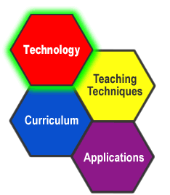

July 24 - 25, 2003
Damon City Campus
Monroe Community College
Rochester, New York

