Speaker Roster for 2003
Paul Velleman


KEYNOTE
Paul Velleman < pfv2@cornell.edu >
15 Lisa Lane, Ithaca, NY 14850, 607-257-0202
358 Ives Hall, Cornell University, Ithaca, NY 14853, 607-255-4411,
Data Description, Inc., 840 Hanshaw Rd, Ithaca, NY 14850, 607-257-1000

AFTER-DINNER
Roger Hoerl


Roger Hoerl < hoerl@crd.ge.com >
General Electric: [518] 387-4040

PANEL
Ginger Rowell

Ginger Holmes Rowell, Ph. D.
Associate Professor of Mathematics
Middle Tennessee State University
Murfreesboro, TN 37132
rowell@mtsu.edu
615.898.5540
Office Hours: TWR 11:00 am - 12:00 noon, 12:30 pm - 2:00 pm CST
New ~ After 11:45 AM CST

PANEL
Webster West
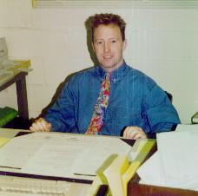
R. Webster West
U of South Carolina,
Columbia, SC 29208
Office Phone: (803) 777-3792
Fax: (803) 777-4048
E-mail: west@stat.sc.edu
websterwest@yahoo.com
Robert Carver
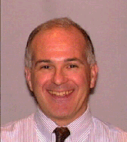
PANEL
Robert H. Carver, Ph.D.
Department of Business Administration
Stonehill College
320 Washington Street
Easton, MA 02357
Telephone: 508-565-1130 FAX: 508-565-1444
e-mail: rcarver@stonehill.edu
http://faculty.stonehill.edu/rcarver
Sterling Hilton
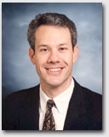

PANEL
Sterling Hilton
Brigham Young University
230 TMCB, Provo, Utah, 846002
hiltons@byu.edu
PHONE: 801-422-6666
OFFICE HOURS 1:00-2:00 M-F

AP STAT
Floyd Bullard
Floyd Bullard
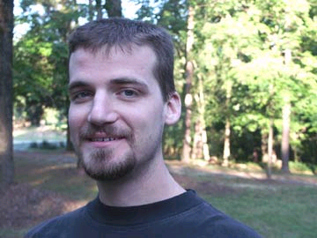
The North Carolina School of Science and Mathematics
1219 Broad Street
Durham, NC 27705
919 241-2741 bullard@ncssm.edu
courses.ncssm.edu/bullard
Michael Larson
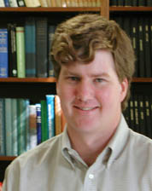

COLLEGE / AP STAT
Michael Larson, University of Chicago
larsen@galton.uchicago.edu
515 292 0300 phone
4633 Hemingway Drive
Ames, Iowa 50014

COLLEGE
John D. McKenzie, Jr., Babson College
mckenzie@babson.edu

CASE STUDY

Paul Velleman, Cornell University
Floyd Bullard, North Carolina School of Science and Mathematics
Robert Carver, Stonehill College
Sterling Hilton, Brigham Young University
Roger Hoerl, General Electric
Michael Larson, University of Chicago
John D. McKenzie, Jr., Babson College
Ginger Holmes Rowell, Middle Tennessee State University
R. Webster West, U of South Carolina

Panel of Carver, Hilton, Rowell, West

Paul Velleman
Floyd Bullard
Robert Carver
Sterling Hilton
Roger Hoerl
Michael Larson
John McKenzie
Ginger Rowell
Web West

pfv2@cornell.edu, rowell@mtsu.edu, websterwest@yahoo.com, rcarver@stonehill.edu, hiltons@byu.edu, bullard@ncssm.edu, hoerl@crd.ge.com, larsen@galton.uchicago.edu, mckenzie@babson.edu

Paul Velleman pfv2@cornell.edu
Floyd Bullard bullard@ncssm.edu
Robert Carver, rcarver@stonehill.edu
Sterling Hilton, hiltons@byu.edu
Roger Hoerl hoerl@crd.ge.com
Michael Larson, larsen@galton.uchicago.edu
John D. McKenzie, mckenzie@babson.edu
Ginger Holmes Rowell, rowell@mtsu.edu
Webster West, websterwest@yahoo.com

