Sixth Annual

Beyond the Formula
Statistics Conference

“Constantly Improving Introductory Statistics:

The Role of Assessment”

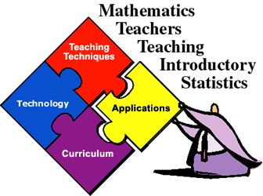

August 8 - 9, 2002
Damon City Campus
Monroe Community College
Rochester, New York

